**Introduction to Computer Vision**

**MBA (BA, AI& ML) - Question Paper**

**Marks: 100**

**Data: 19-03-2021**

1. **Explain the Morphological operations in image processing with code? (10 Marks)**
2. **Describe briefly about RANSAC Algorithm? (10 Marks)**
3. **Explain the geometric transformations in 2D and 3D images? (10 Marks)**
4. **Explain the intrinsic and extrinsic parameter of camera with appropriate equations? (10 Marks)**
5. **What is the use of Epipolar geometry and its applications? (10 Marks)**
6. **Find the errors in this corner detection program and detect the edges in the input image?**

**(10 Marks)**

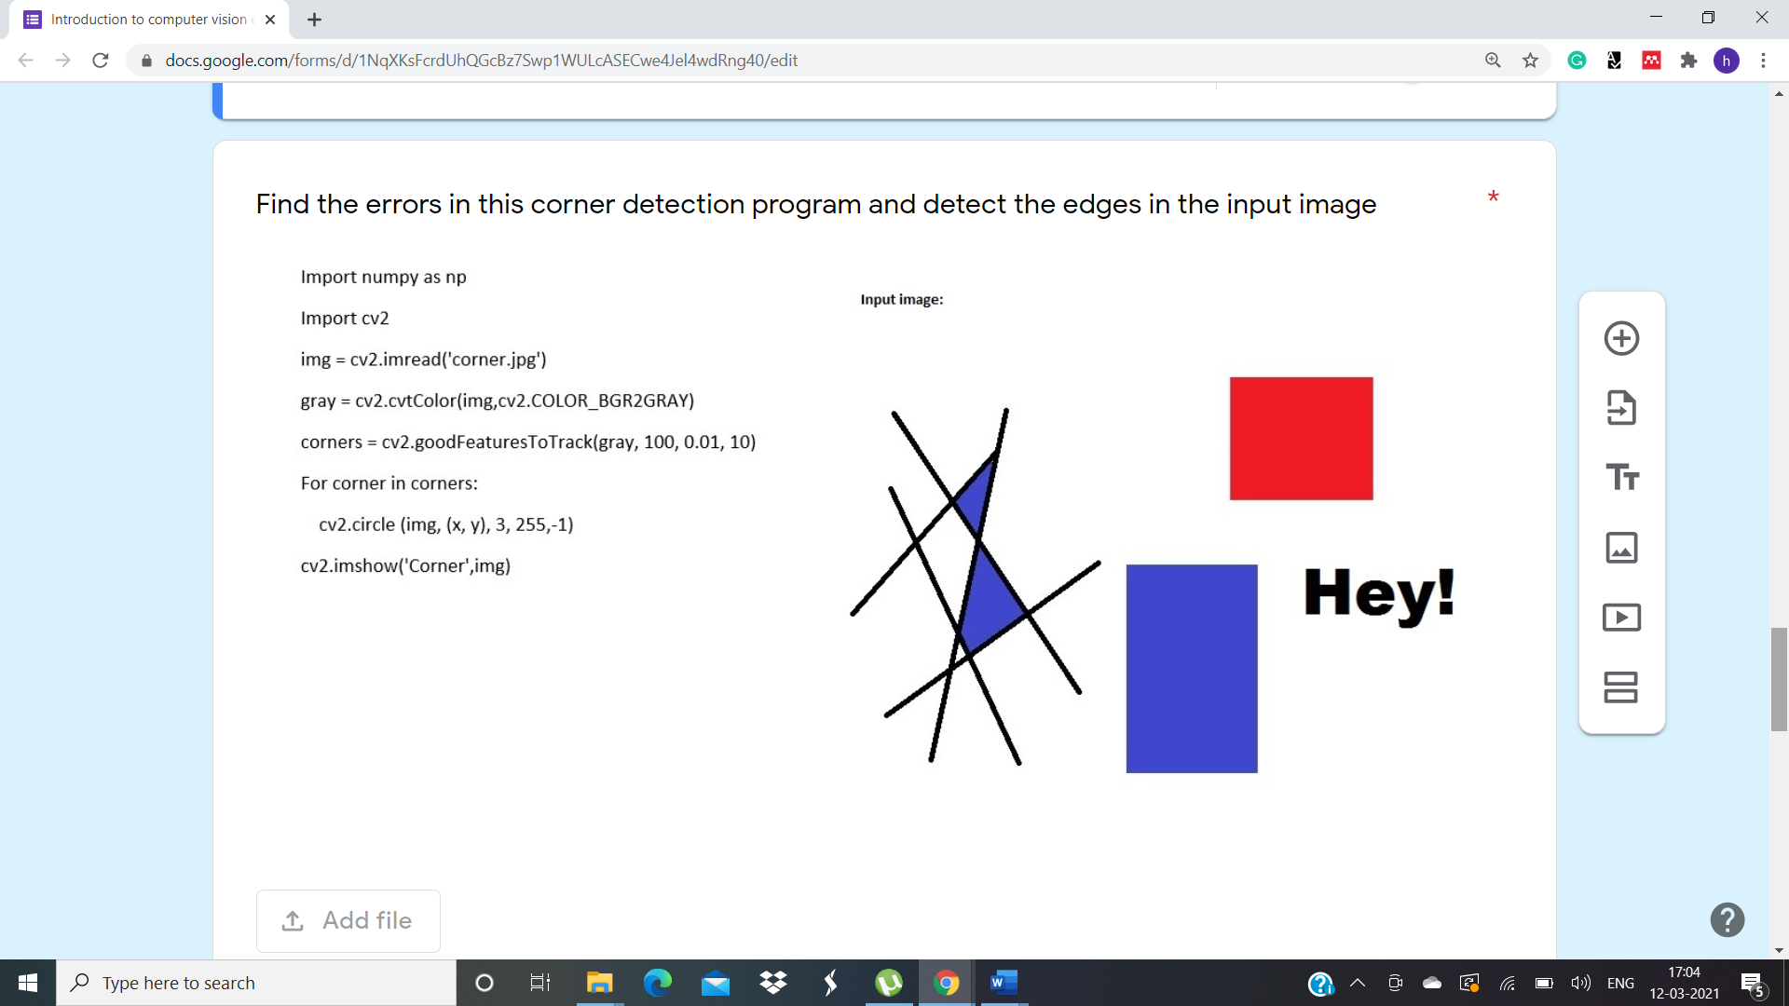

1. **Write a code to access your webcam and scan any document. Once you scan it, then preprocess the image and apply contours and warp on that image. (20 Marks)**
2. **Write a program to apply adaptive mean and gaussian thresholding for this image and display the output (20 Marks)**

